**EXPERIMENT NO 3: Date:06/03/2023**

**AIM :**

Familiarization of linux command.

**C02 :**

Perform system administration task.

**Procedure :**

1. pwd – print the working directory

$ pwd

**Output :**

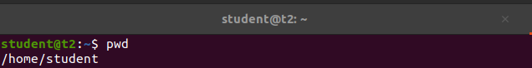

1. ls – To list the directory

$ ls

**Output :**



2.1. ls -R – It shows sub directories file

$ ls -R

**Output:**

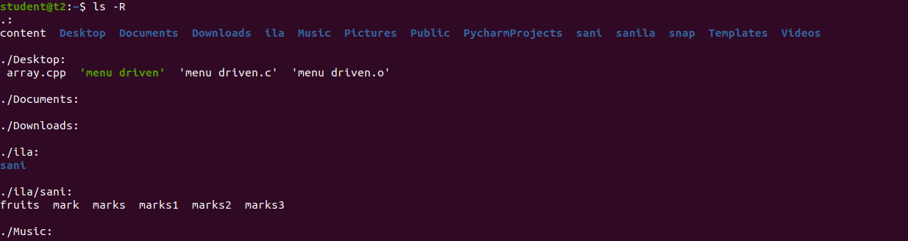

2.2. ls -l -Long listing the contents

$ ls -l

**Output :**

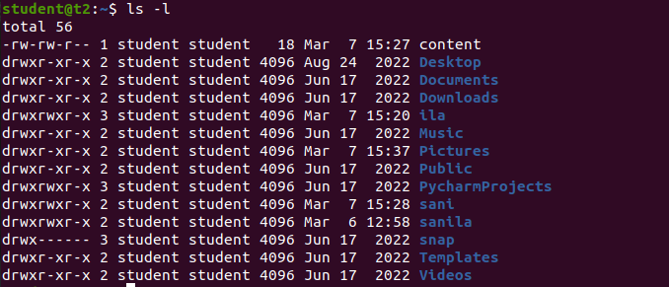

2.3. ls -a -List hidden files

$ ls -a

**Output :**



2.4. ls -al -List the files and directory with detailed information with detailed information with permission, owner, file size etc.

$ ls -al

**Output :**

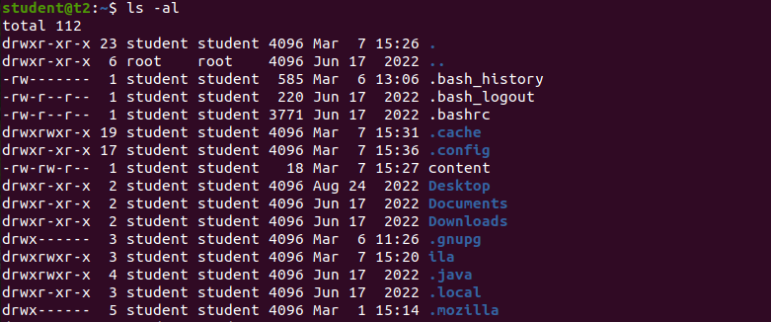

2.5. ls -t - List the files sorted in the order of last modified.

$ ls -t

**Output :**



2.6. ls -r - To reverse the natural sorting order.

$ ls -r

**Output :**



1. history -To review the command that have been previously executed for certain period of time.

$ history

**Output :**

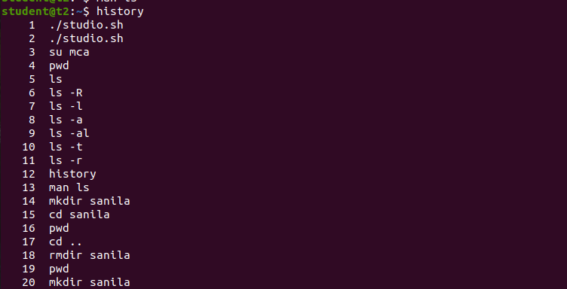

1. man – we can learn and understand about different command write from the shell using man command

$ man ls

**Output :**

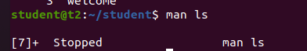

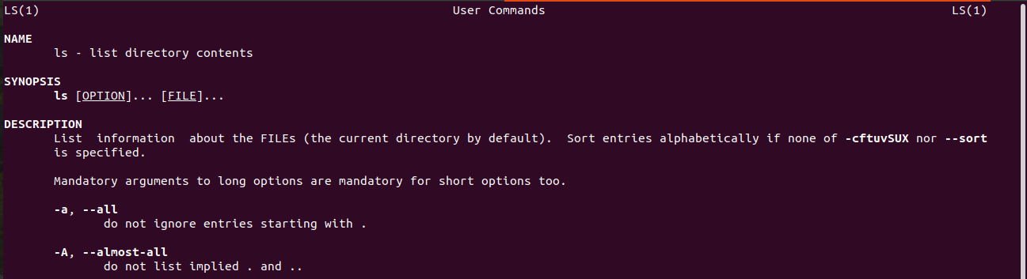

1. mkdir – To create a new directory.

$ mkdir names

$ cd names

**Output :**



1. rmdir – To remove the directory.

$ rmdir names

**Output :**

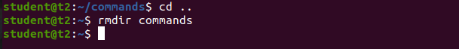

1. touch – To create files

$ touch names

**Output :**



1. cat – Concatenate the files and print on the standard output

$cat

a. cat > filename.txt – To create a file with inserting contents

$cat > file.txt

**Output:**

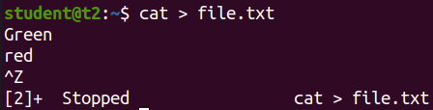

b. cat filename.txt – To view the content of the file

$cat file.txt

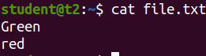 **Output:**

c. cat >> filename.txt – To append new contents to an existing file

$cat >> file.txt

**Output:**

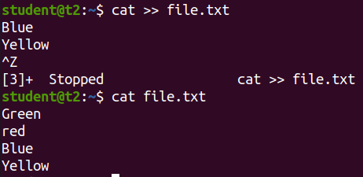

d. cat -n filename.txt – Number all output lines

$cat -n file.txt

**Output:**

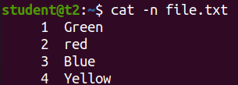

e. cat -b filename.txt – To remove the empty lines

$cat -b file.txt

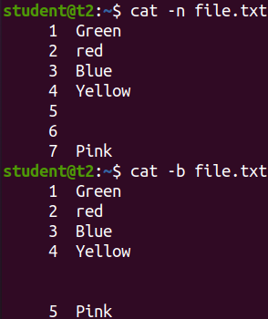 **Output:**

f. cat -E filename.txt – Display $ at end of each line

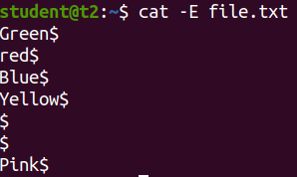 $cat -E file.txt

**Result:**

The program was executed and the result was successfully obtained. Thus CO2 was obtained.